Software Design Document
Smart Plant Doctor



Submitted by
Ubaid ur Rehman
F22BINFT1E02113
Submitted to
Dr Muhammad Asad Ullah

Department of Information Technology
Faculty of Computing
The Islamia University of Bahawalpur

Summery
This Software Design Document (SDD) describes the complete design of the Smart Plant Doctor application,The Smart Plant Doctor is an AI-powered mobile application designed to assist users—especially farmers, gardeners, and plant enthusiasts—in identifying plant diseases and providing actionable treatment recommendations. It combines advanced image recognition using Convolutional Neural Networks (CNNs) with natural language processing via Large Language Models (LLMs) to deliver accurate, human-readable insights.
The system follows a modular, scalable architecture. Users interact through a mobile application that allows easy capture or upload of plant images. The backend, deployed on cloud infrastructure, processes the data, interacts with the AI models, stores user and image data, and delivers results efficiently. The hybrid database system combines relational storage for structured data (user profiles, disease results, treatment recommendations) and cloud storage for unstructured data (images, AI model outputs).
Key features include:
- AI-driven disease detection with high accuracy and confidence scores.
- Treatment recommendations with step-by-step instructions and references.
- User-friendly interfaces including a home dashboard, image capture interface, results display, and history tracking.
- Accessibility and responsiveness, supporting a variety of devices and user needs.
- Data integrity and security, using encryption, validation, and secure cloud storage.
The Smart Plant Doctor not only reduces the time and effort required to identify plant diseases but also empowers users with reliable recommendations to maintain healthy plants, reduce crop losses, and optimize plant care. It bridges technology and agriculture to provide intelligent, real-time plant diagnostics accessible to everyone.

Table of Content
1. Application Architecture
1.1 Overall System Architecture
1.2 Client–Server Architecture
1.3 Mobile Application Layer
1.4 Backend & Cloud Architecture
1.5 AI Processing Layer
1.6 Integration of CNN and LLM
1.7 Security Architecture
1.8 Deployment Architecture
2. Data Model Schema
2.1 Data Flow Description
2.2 Database Design Overview
2.3 Entity Relationship (ER) Diagram
2.4 User Data Schema
2.5 Plant Image Data Schema
2.6 Disease Detection Result Schema
2.7 Treatment Recommendation Schema
2.8 Firebase / Cloud Storage Structure
2.9 Data Validation and Constraints
3. User Interface
3.1 UI Design Principles
3.2 Application Navigation Flow
3.3 Splash Screen Design
3.4 User Registration & Login Screens
3.5 Home Dashboard Interface
3.6 Plant Image Capture Interface
3.7 Disease Detection Result Screen
3.8 Treatment Recommendation Screen
3.9 History & Saved Results Screen
3.10 Error & Alert Message Design
3.11 Accessibility Considerations

1. Application Architecture

1.1 Overall System Architecture
The application is designed using a modular and scalable architecture to handle multiple users, provide AI-driven insights, and ensure real-time processing. The system follows a layered architecture, ensuring separation of concerns and ease of maintenance.
Key Components:
- Client Layer: Mobile application for users.
- Backend Layer: RESTful APIs or GraphQL for communication.
- Database Layer: Relational (SQL) and NoSQL for structured and unstructured data.
- AI Processing Layer: Convolutional Neural Networks (CNN) for image processing and Large Language Models (LLM) for natural language understanding.
- Cloud & Deployment Layer: Cloud hosting (AWS, GCP, or Azure) with containerized deployment for scalability.

1.2 Client–Server Architecture
The system uses a client-server model where:
- Clients (mobile apps) send requests to the server.
- Server handles authentication, business logic, AI processing requests, and responds with structured data.
Benefits:
- Scalability: Multiple clients can connect concurrently.
- Centralized control: Security and data management are handled at the server.
- Flexible upgrades: AI models and backend logic can be updated without client-side changes.

1.3 Mobile Application Layer
The mobile application is designed with cross-platform frameworks (Flutter or React Native) for Android and iOS support.
Key Features:
- User Authentication and Profile Management
- Image Upload & Real-Time Processing
- Interactive UI for AI insights
- Offline Mode & Local Caching
Architecture:
- UI Layer: Screens, Widgets, Components
- Business Logic Layer: State management (Provider, Bloc, or Redux)
- Network Layer: API calls, error handling, response parsing

1.4 Backend & Cloud Architecture
The backend is designed using microservices architecture for modularity:
- API Gateway: Handles routing, authentication, and throttling
- User Management Service: Authentication, authorization, user profile
- AI Service: Handles requests to CNN and LLM models
- Data Service: Database interactions and caching mechanisms
Cloud Infrastructure:
- Compute: Docker containers orchestrated with Kubernetes
- Storage: Cloud SQL + S3 for image data
- Load Balancing & Auto-scaling for high availability

1.5 AI Processing Layer
The AI layer includes:
- CNN for Image Recognition: Detects patterns, diseases, or objects from images
- LLM for Natural Language Understanding: Processes user queries and generates responses
- Model Management: Version control, updating models without downtime
Processing Flow:
- Mobile app uploads image/data
- Backend preprocesses input
- CNN detects features
- LLM interprets results and generates explanation
- Response sent to client

1.6 Integration of CNN and LLM
The system integrates CNN and LLM for multimodal AI processing:
- CNN outputs: Feature vectors or classification labels
- LLM inputs: Structured CNN output plus user text query
- LLM outputs: Human-readable insights, recommendations, or reports
Benefits:
- Accurate predictions from visual data
- Contextual explanations via natural language
- Supports advanced AI features like recommendations or diagnostics

1.7 Security Architecture
Security is implemented using a multi-layer approach:
- Authentication & Authorization: OAuth 2.0 / JWT
- Data Encryption: TLS for data in transit, AES-256 for data at rest
- Access Control: Role-based access control (RBAC)
- Monitoring: Intrusion detection, anomaly detection logs
- Cloud Security: VPC, firewall rules, identity and access management (IAM)

1.8 Deployment Architecture
The application uses CI/CD pipelines for automated deployment:
- Dockerized Microservices deployed on Kubernetes
- Load Balancers for handling concurrent users
- Auto-Scaling Groups for performance optimization
- Monitoring & Logging: Prometheus, Grafana, ELK stack
Deployment Strategies:
- Blue-Green deployment for minimal downtime
- Canary release for AI model updates
- Cloud backups and disaster recovery

1.9 Additional Considerations
- Scalability: Both horizontal and vertical scaling of backend services
- Maintainability: Modular code, version control for AI models
- Reliability: Fault-tolerant architecture with failover mechanisms
- Analytics: Integration with analytics tools for usage and AI model performance
Application Architecture
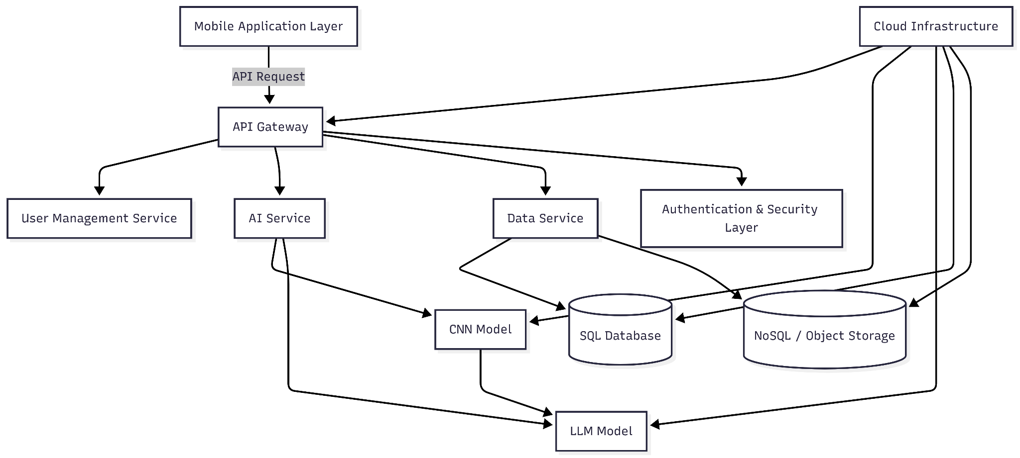

Explanation of Diagram:
- A → B: Mobile app sends requests through API Gateway.
- B → C/D/E: Gateway routes to backend microservices.
- D → F/G: AI service processes CNN and LLM tasks.
- F → G: CNN features passed to LLM for interpretation.
- E → H/I: Data services manage structured and unstructured data.
- J: Security layer integrated across services.
- K: All services hosted on cloud infrastructure with scalability and monitoring.

2. Data Model

2.1 Data Flow Description
The data flow of the application is designed to handle user interactions, AI processing, and storage efficiently. Users interact with the mobile application by uploading plant images and optionally providing text-based queries. The backend first validates and sanitizes this data, ensuring all inputs meet the required format. Images are then sent to the AI processing layer where the Convolutional Neural Network (CNN) analyzes them to detect diseases, and the results are further interpreted by the Large Language Model (LLM) to provide human-readable insights. These outputs are stored along with metadata, and recommendations are generated and returned to the mobile application for display.

2.2 Database Design Overview
The database design is a hybrid of relational and NoSQL paradigms. Structured data, such as user profiles, disease detection results, and treatment recommendations, is stored in a relational database to maintain data integrity and relationships. Unstructured data, including plant images and AI-generated intermediate data, is stored in cloud object storage or Firebase. This design allows scalable storage for large datasets and supports high-performance queries for AI processing results.

2.3 Entity Relationship (ER)
The core entities in the system include User, PlantImage, DiseaseDetectionResult, and TreatmentRecommendation. A single User can upload multiple PlantImages, each of which has a one-to-one relationship with a DiseaseDetectionResult. Each DiseaseDetectionResult can generate multiple TreatmentRecommendations. This ER model ensures traceability from users to images, detected diseases, and suggested treatments, maintaining consistency across all data points.

2.4 User Data Schema
The user data schema defines how personal and account-related information is stored. Each user has a unique identifier, a name, an email address, a hashed password for security, and timestamps for account creation and last login. This schema ensures users are uniquely identifiable, and sensitive data is protected through encryption.

2.5 Plant Image Data Schema
Each plant image uploaded by a user is stored with a unique identifier, a reference to the owner (user ID), a cloud storage URL for the image file, the timestamp of upload, and optionally, the plant type. The schema allows linking each image to the user who uploaded it and to the AI processing results generated from it.

2.6 Disease Detection Result Schema
Each plant image generates a disease detection result stored with a unique result identifier and a reference to the related image. The schema includes the disease name detected by the CNN, a confidence score indicating prediction certainty, and a timestamp for when detection occurred. This ensures that AI outputs are traceable to the original input images.

2.7 Treatment Recommendation
Based on the disease detection results, treatment recommendations are stored as separate entities. Each recommendation has a unique identifier, a reference to the corresponding disease detection result, a description of the treatment, detailed instructions if needed, and optional source references. This allows multiple recommendations to be linked to a single detection result.

2.8 Firebase / Cloud Storage
The cloud storage structure is hierarchical for easy organization and retrieval. At the top level is the application storage directory, which contains subdirectories for users, logs, and AI models. Each user has a folder containing profile information and an images folder storing uploaded and processed plant images. Logs are stored by timestamp, and AI models are version-controlled in dedicated folders. This structure ensures scalability, maintainability, and efficient access.

2.9 Data Validation and Constraints
Data validation ensures the integrity, security, and correctness of stored information. Unique constraints enforce that emails, user IDs, and image IDs are not duplicated. Foreign key constraints maintain relationships between users, images, detection results, and recommendations. Validation also ensures numeric fields like confidence scores fall within valid ranges, timestamps are valid, and input formats like image types and sizes are restricted. Security measures include hashed passwords, encrypted sensitive fields, and secure storage URLs.
Diagram for Data Model
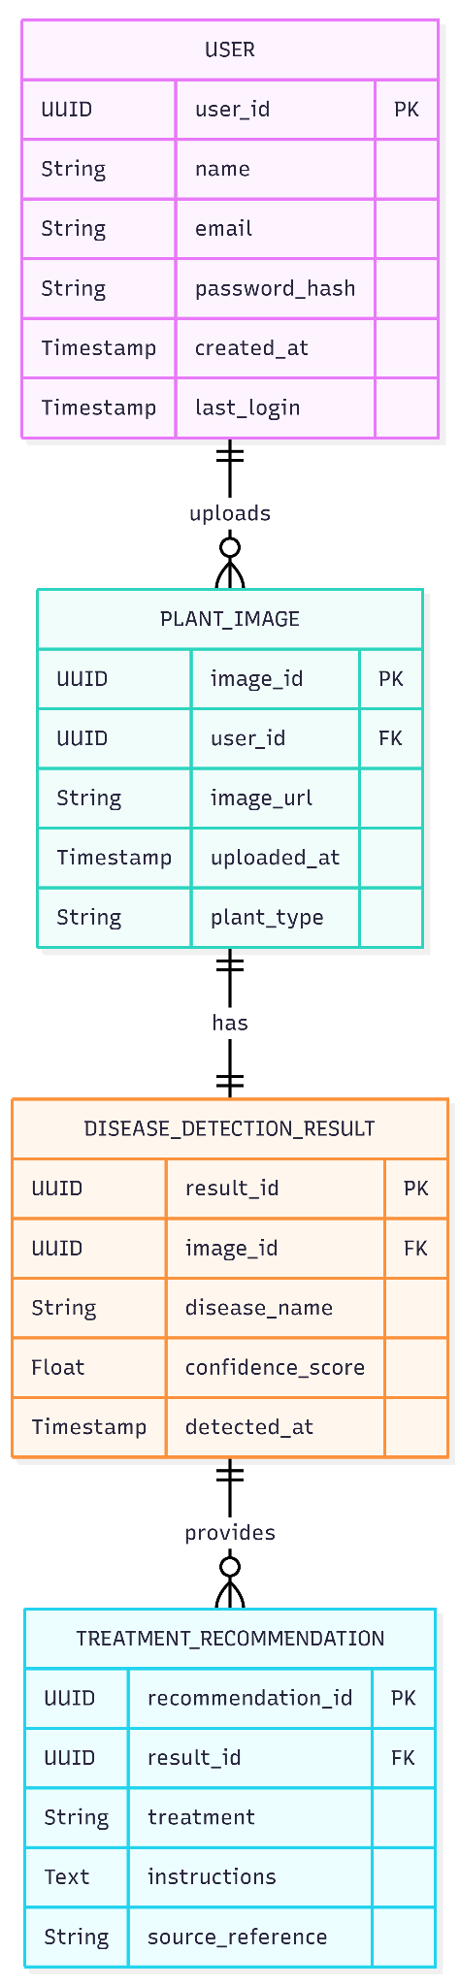
Diagram Explanation:
- Users can upload multiple plant images.
- Each plant image generates one disease detection result.
- Each detection result can have multiple treatment recommendations.
- Relationships are maintained via foreign keys, ensuring traceability and consistency.

3. User Interface

3.1 UI Design Principles
The application’s UI is designed to be intuitive, consistent, and responsive. The primary principles guiding the design include simplicity, minimalism, and clarity. Key considerations:
- Consistency: Similar elements use the same colors, fonts, and icons across all screens.
- Visual Hierarchy: Important actions and results are prominently displayed.
- Feedback: Users receive clear feedback for interactions, such as loading indicators, success messages, and error alerts.
- Responsiveness: The UI adapts to different screen sizes for both mobile devices and tablets.
- Accessibility: Supports screen readers, high-contrast themes, and scalable fonts.

3.2 Application Navigation Flow
The application uses a bottom navigation bar and a stacked screen flow for intuitive navigation. Users can quickly move between the home dashboard, plant capture, history, and settings. Context-specific actions, such as capturing a new image or viewing a detection result, use modal or detail screens to reduce cognitive load.

3.3 Splash Screen Design
The splash screen provides the first impression of the application. It features the app logo, tagline, and an animated loading indicator. The screen is displayed briefly while the backend services and AI models initialize. A visually appealing splash helps improve user retention and reinforces brand identity.

3.4 User Registration & Login Screens
The registration and login screens are simple and secure. Users can register via email/password or OAuth login (Google, Apple, etc.).
- Registration requires name, email, and password with validation checks for strong credentials.
- Login provides options for password reset and biometric authentication (fingerprint or face recognition).
- Clear error messages guide users when invalid inputs are provided.

3.5 Home Dashboard Interface
The home dashboard is the central hub of the application. It displays:
- Quick access to capture a new plant image
- Recent disease detection results and recommendations
- Notifications, tips, and AI insights
The layout is modular, with cards and sections that can be scrolled vertically. Important actions are highlighted using contrasting buttons and colors.

3.6 Plant Image Capture Interface
The capture interface allows users to take photos of plants using the device camera or upload from the gallery. Features include:
- Auto-focus and grid overlay for proper framing
- Option to annotate or add plant type information
- Preview of the image before submission for AI analysis
- Capture button prominently placed for easy access

3.7 Disease Detection Result Screen
After AI processing, the result screen displays:
- The plant image with highlighted areas of concern (e.g., affected leaves)
- Detected disease name and confidence percentage
- Option to get detailed information or explanations from the AI model
- Buttons to save, share, or proceed to treatment recommendations

3.8 Treatment Recommendation Screen
This screen provides actionable advice for the detected disease. Features include:
- Step-by-step treatment instructions
- Suggested remedies, chemicals, or natural treatments
- Optional reference links for further reading
- Save or share options for easy access later

3.9 History & Saved Results Screen
The history screen provides users with a timeline of previously uploaded plant images, detected diseases, and treatment recommendations. Features:
- Filter by date, plant type, or disease
- Quick access to previous results for comparison
- Option to delete or archive old records

3.10 Error & Alert Message Design
Error messages and alerts are designed to be informative and actionable. They appear as snackbars, modals, or toast notifications depending on severity. Examples:
- Network errors trigger retry options
- Invalid image uploads show guidance on correct formats
- Confirmation dialogs appear before irreversible actions (e.g., deleting history)

3.11 Accessibility Considerations
The UI is designed to be accessible to all users:
- Supports screen readers with proper labeling of buttons and images
- High-contrast mode for visually impaired users
- Scalable fonts and responsive layouts for varying device sizes
- Voice commands for navigation in critical workflows
Application UI Flow
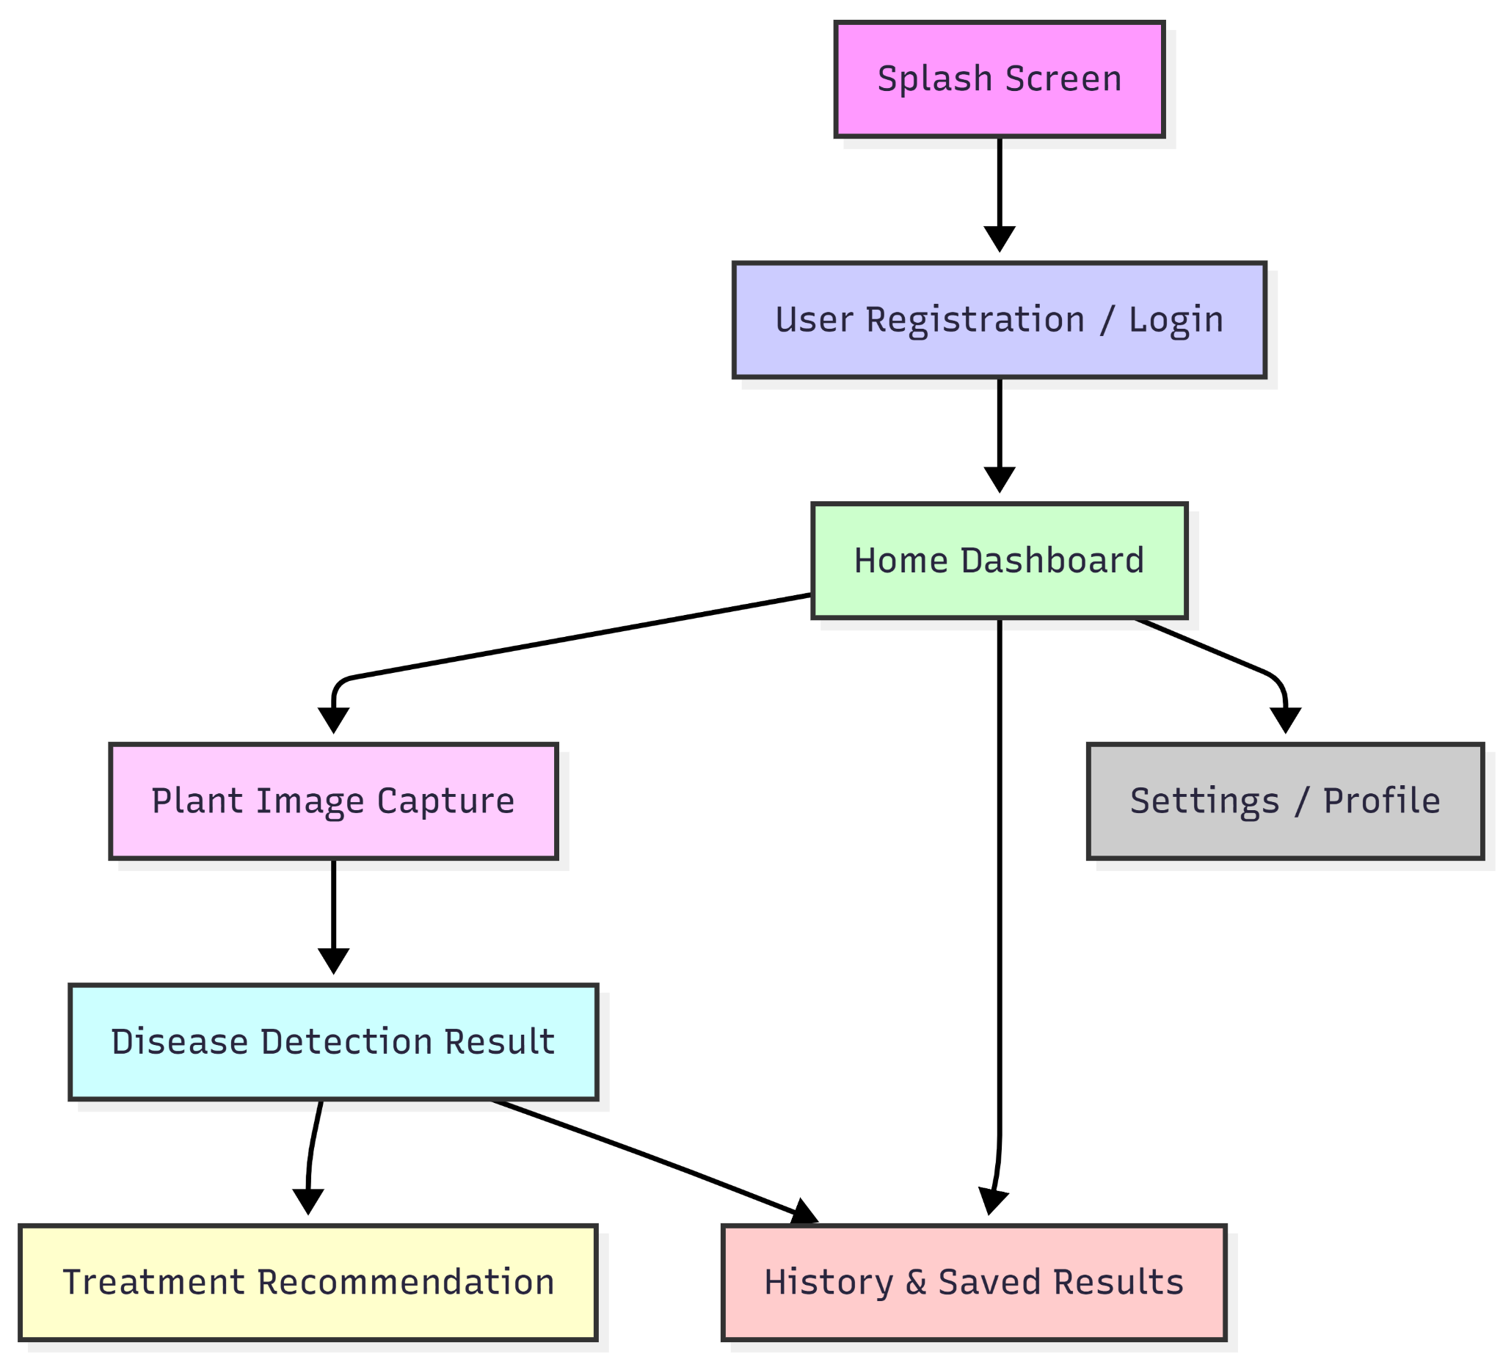
Diagram Explanation:
- The flow starts from the Splash Screen and moves to Registration/Login.
- Users reach the Home Dashboard from which they can capture a plant image, view history, or go to settings.
- Captured images go to Disease Detection Result, which then leads to Treatment Recommendations.
- History and saved results are accessible from both the dashboard and result screens.
References
- Goodfellow, I., Bengio, Y., & Courville, A. (2016). Deep Learning. MIT Press.
- LeCun, Y., Bengio, Y., & Hinton, G. (2015). Deep learning. Nature, 521(7553), 436–444.
- Chollet, F. (2017). Deep Learning with Python. Manning Publications.
- Russakovsky, O., et al. (2015). ImageNet Large Scale Visual Recognition Challenge. International Journal of Computer Vision, 115(3), 211–252.
- Vaswani, A., et al. (2017). Attention is All You Need. Advances in Neural Information Processing Systems, 30.
- Firebase Documentation. (2025). Firebase Cloud Storage and Firestore. Retrieved from https://firebase.google.com/docs
- TensorFlow Documentation. (2025). TensorFlow for Image Recognition and CNNs. Retrieved from https://www.tensorflow.org
- Microsoft Azure AI Documentation. (2025). Deploying AI Models in the Cloud. Retrieved from https://learn.microsoft.com

